**Marachu Chandra Sekhar**

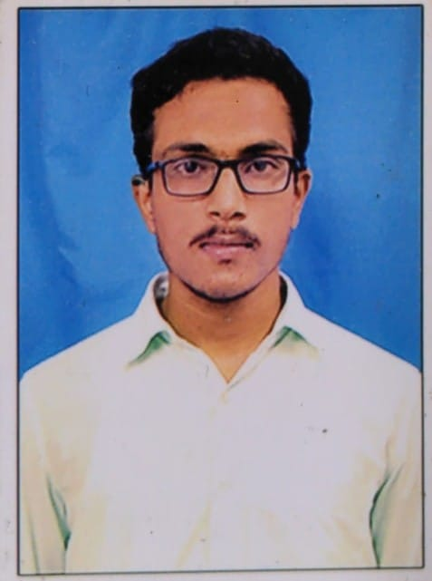

[marachuc1@newpaltz](mailto:marachuc1@newpaltz).edu

845-633-1485

I did my bachelor’s in computer science from Narasaraopeta Engineering College and during my bachelor’s I did some projects based on Python and Angular JS i.e; Campus Recruitment System & Personal Profile and also did some certifications on Udemy and Coursera which are Angular JS, Node JS and Python that I did those up to an intermediate level. Along with these I participated as an intern at ZeroClientglobal on Angular9 Framework and Node JS.

I want to learn this Course to a full extent as I want to be a Full-Stack Developer and I know this course is a bit hard so, I want to learn this completely as it takes place a major role when I proceed for job.